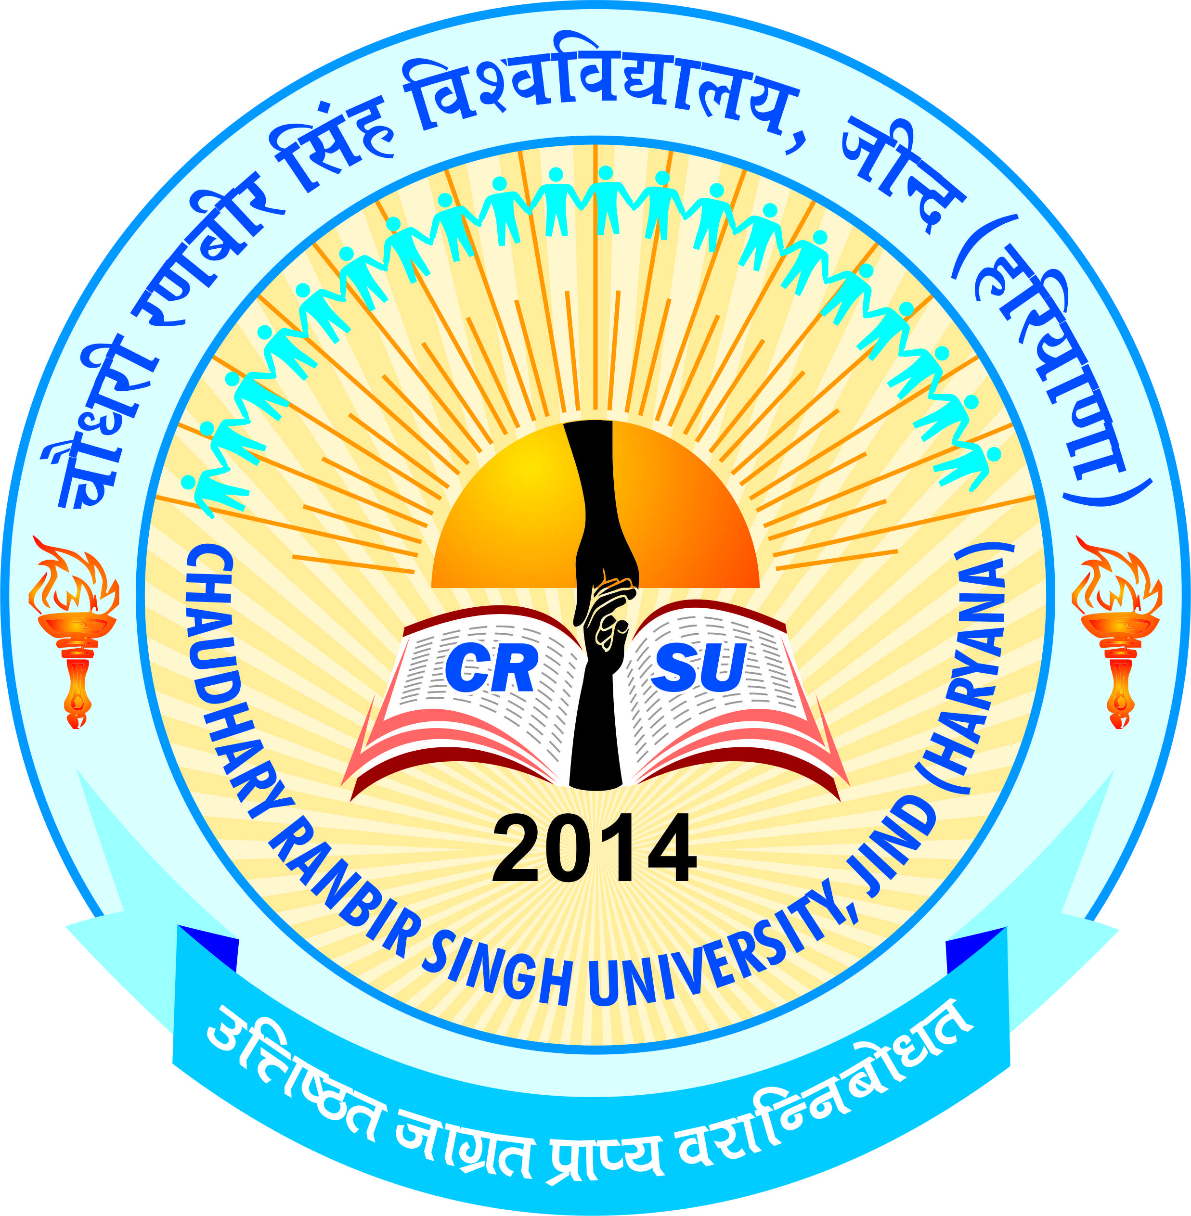 | pkS/kjh j.kchj flag fo'ofo|ky;]thUn  Chaudhary Ranbir Singh University, Jind  (Established by the State Legislature Act 28 of 2014 and recognized U/S 2(f) & 12-B by UGC Act 1956) | 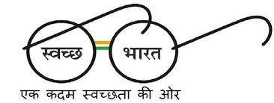

Admission for B.El.Ed four year Professional Degree Programme
Online applications are invited from candidates for admission in B.El.Ed four year Professional Degree Programme being run in Nakshatra Vidyapeeth, Khudana, Mohindergarh and R.S. Memorial College of Education, Buana Lakhu, Panipat Colleges affiliated to this University. The Prospectus containing all the details will be available on University website i.e. www.crsu.ac.in, w.e.f. 26/09/2018. The Opening Date of Online Registration is 26-09-2018 and Closing Date is 12-10-2018.

REGISTRAR

